Group :2

Gaurav Sipani

Madhav Sampath

Arushi Mittal

Srilekha Boddu

**SQL-Mongo Project – Spatial Data of US Wildfires**

BUAN 6320

|  |  |  |  |  |
| --- | --- | --- | --- | --- |
| **Activity** | **Member 1** | **Member 2** | **Member 3** | **Member 4** |
| Prepared Data Model and Created Physical DB | X | X | X | X |
| Loaded Data into Database | X | X | X | X |
| Wrote SQL Queries |  |  |  |  |
| Prepared Mongo Database |  |  |  |  |
| Loaded data into Mongo DB |  |  |  |  |
| Wrote Mongo Queries |  |  |  |  |
| Prepared Report |  |  |  |  |
| Reviewed Report |  |  |  |  |

Contents

Data Model 5

Assumptions/Notes About Data Entities and Relationships 5

Entity-Relationship Diagram 5

Physical Database 6

Assumptions/Notes About Data Set 6

Screen shot of Physical Database objects 6

Data in the Database 6

SQL Queries 7

Query 1 7

Question 7

Notes/Comments About SQL Query and Results (Include # of Rows in Result) 7

Translation 7

Screen Shot of SQL Query and Results 7

Query 2 8

Question 8

Notes/Comments About SQL Query and Results (Include # of Rows in Result) 8

Translation 8

Screen Shot of SQL Query and Results 8

Query 3 9

Question 9

Notes/Comments About SQL Query and Results (Include # of Rows in Result) 9

Translation 9

Screen Shot of SQL Query and Results 9

Query 4 10

Question 10

Notes/Comments About SQL Query and Results (Include # of Rows in Result) 10

Translation 10

Screen Shot of SQL Query and Results 10

Query 5 11

Question 11

Notes/Comments About SQL Query and Results (Include # of Rows in Result) 11

Translation 11

Screen Shot of SQL Query and Results 11

Query 6 12

Question 12

Notes/Comments About SQL Query and Results (Include # of Rows in Result) 12

Translation 12

Screen Shot of SQL Query and Results 12

Data Review for MongoDB 13

Assumptions/Notes About Data Collections, Attributes and Relationships between Collections 13

Physical Mongo Database 14

Assumptions/Notes About Data Set 14

Screen shot of Physical Database objects (Database, Collections and Attributes) 14

Data in the Database 14

MongoDB Queries/Code 15

Query 1 15

Question 15

Notes/Comments About MongoDB Query/Code and Results (Include # of Documents in Result) 15

Translation 15

Screen Shot of MongoDB Query/Code and Results 15

Query 2 16

Question 16

Notes/Comments About MongoDB Query/Code and Results (Include # of Documents in Result) 16

Translation 16

Screen Shot of MongoDB Query/Code and Results 16

Query 3 17

Question 17

Notes/Comments About MongoDB Query/Code and Results (Include # of Documents in Result) 17

Translation 17

Screen Shot of MongoDB Query/Code and Results 17

Query 4 18

Question 18

Notes/Comments About MongoDB Query/Code and Results (Include # of Documents in Result) 18

Translation 18

Screen Shot of MongoDB Query/Code and Results 18

Query 5 19

Question 19

Notes/Comments About MongoDB Query/Code and Results (Include # of Documents in Result) 19

Translation 19

Screen Shot of MongoDB Query/Code and Results 19

Query 6 20

Question 20

Notes/Comments About MongoDB Query/Code and Results (Include # of Documents in Result) 20

Translation 20

Screen Shot of MongoDB Query/Code and Results 20

# Data Model

## Assumptions/Notes About Data Entities and Relationships

Assumption:

1. From the SQLite dataset only fires, NWGC unit details table provides the information required
2. To remove the null values we have created separate data tables for ICS_209_NUMBER and MTBS_details
3. The NWGC Reporting Agency data will be stored in NWGC – Unit_Details table.
4. Latitude and Longitude is used as composite key to define the location of the fire incident
5. Size of the area where the fire incident took place are divided into various classes like 0 but less than 0.25 acres is A.
6. There are various agency that prepares the report of incidents which took place at a certain locations
7. The column county in the fire table from the SQLite dataset does not have a normalized entry**.**

Relationship:

1. One Fire detail can have zero to many ICS_209_INCIDENT_NUMBER
2. One Fire detail can have zero to many MTBS_ID
3. One SOURCE_REPORTING_UNIT will one to many Fire incidents details
4. A Fire_size can be assigned to one to many fire incidents.
5. A Fire Location can have one or many fire incidents.
6. One Owner can have one to many fire incidents and one fire incident can take place in a location that have only one owner.
7. One NWGC Reporting Agency can report one to many fire incidents but one fire incident can be reported by one agency.
8. A Stat_cause will have one to many fire incidents but one fire incident will have only one Stat_cause

Include reasons why the data model is in 3NF.

* Each table has its own functionality.
* Every table has a primary key and each table contains only atomic values which satisfies the condition of 1NF.
* Every column in each table is dependent on a single primary key and there are no partial dependencies.
* There are no transitive functional dependencies between any column in table which satisfies the condition of 3NF

## Entity-Relationship Diagram

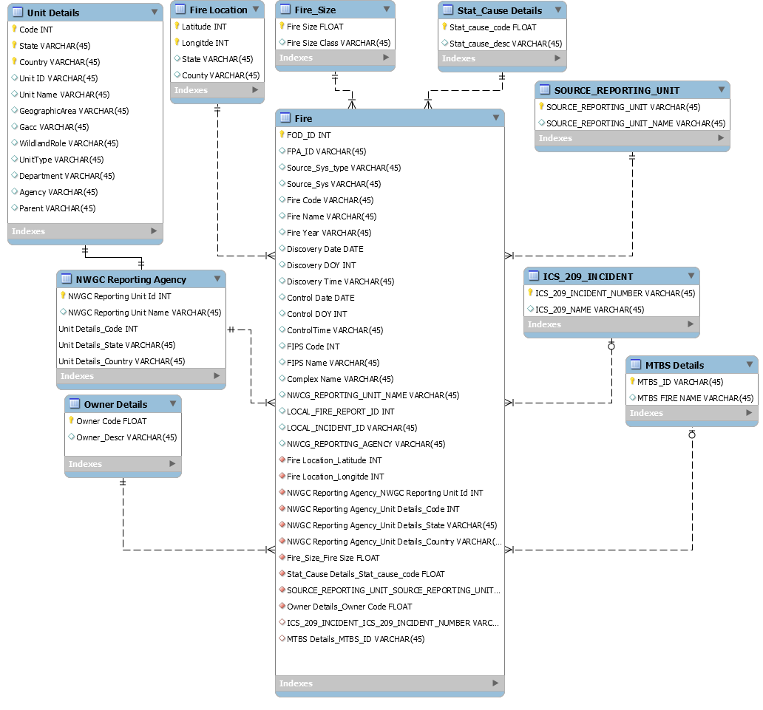

# Physical Database

## Assumptions/Notes About Data Set

Include any assumptions made about data such as empty fields, sparse data, bad data, etc.

## Screen shot of Physical Database objects

Database:

Fire

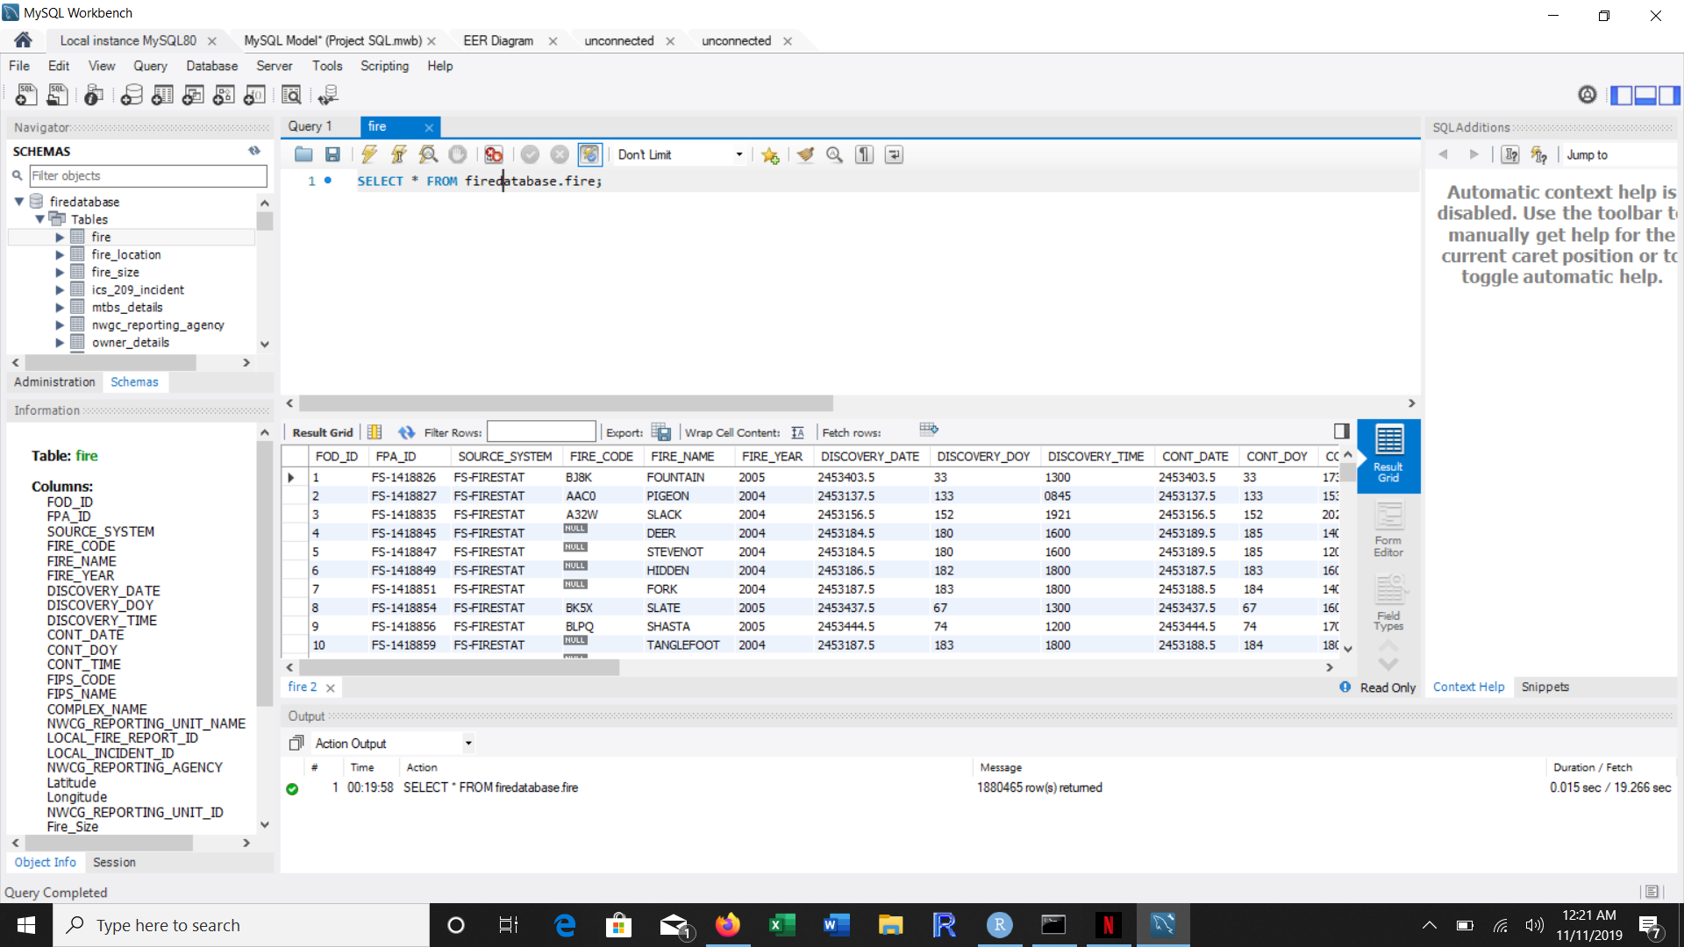

Ics_209_incident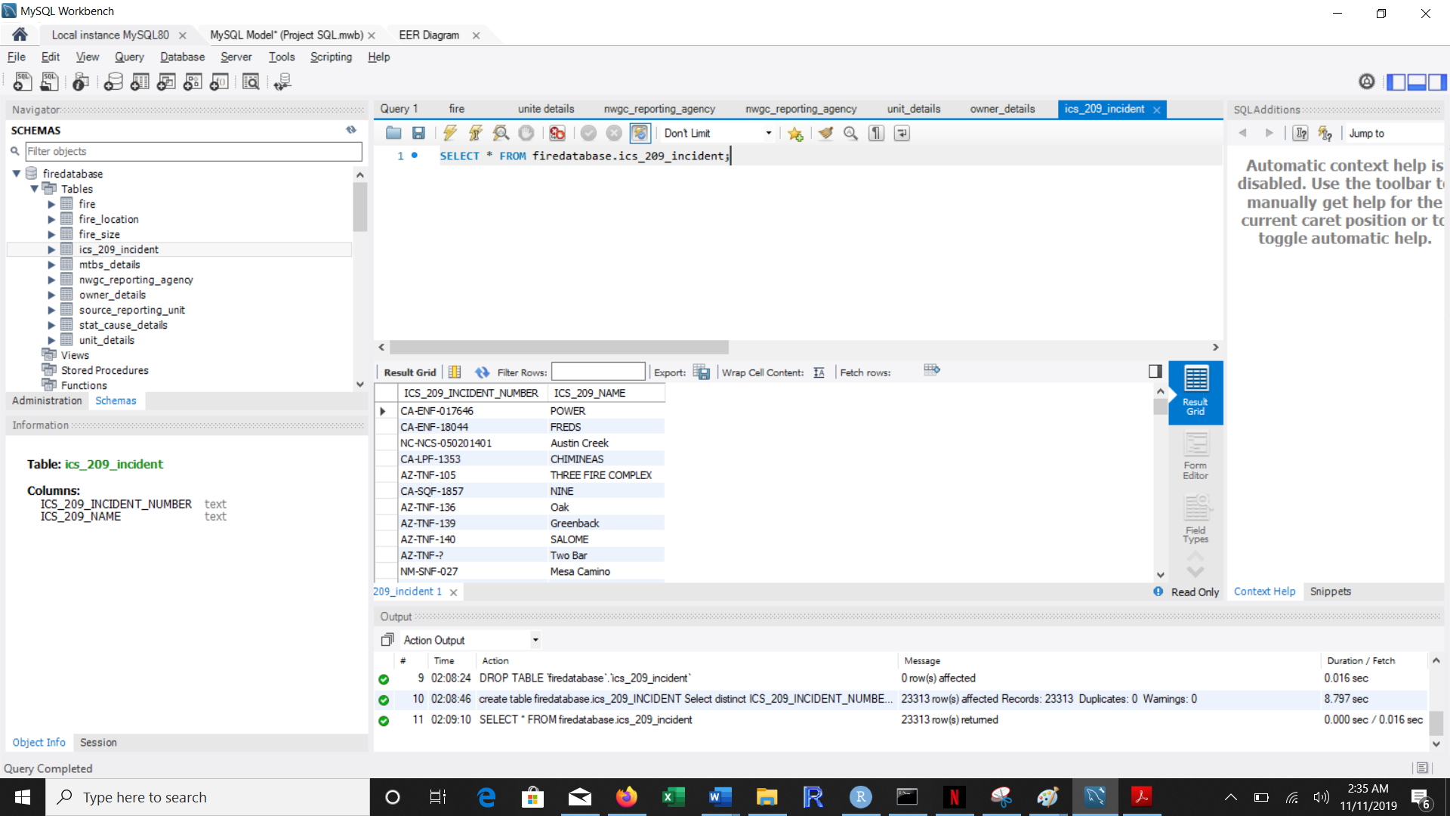

MTBS Details

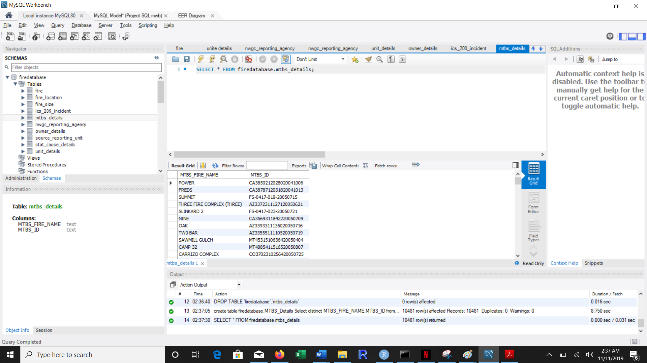

Source reporting unit

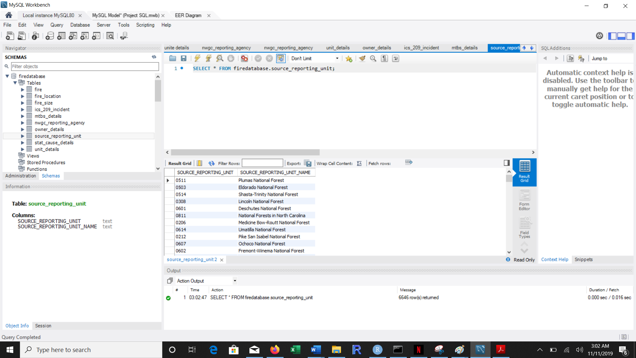

Stat cause details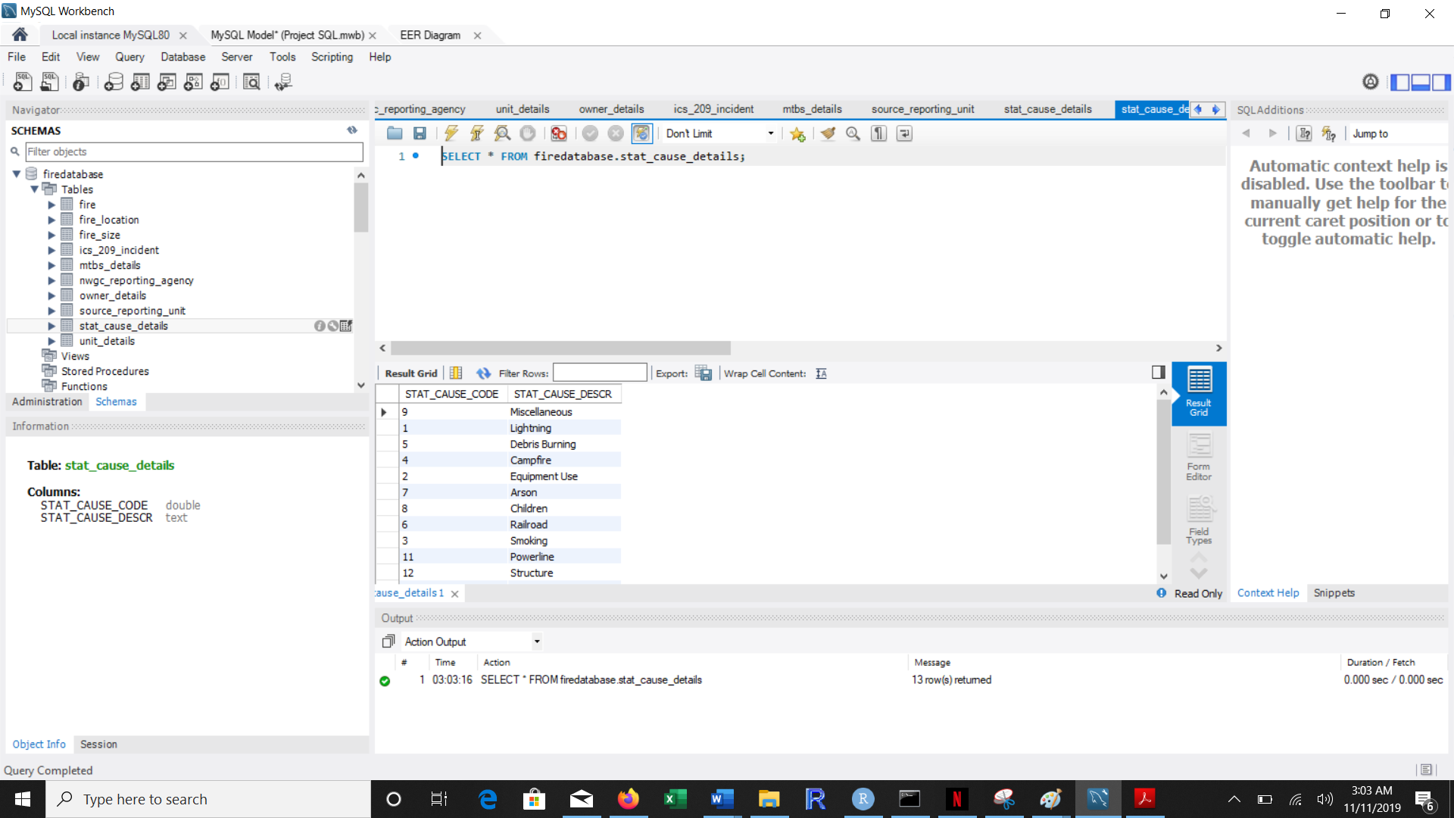

Fire size

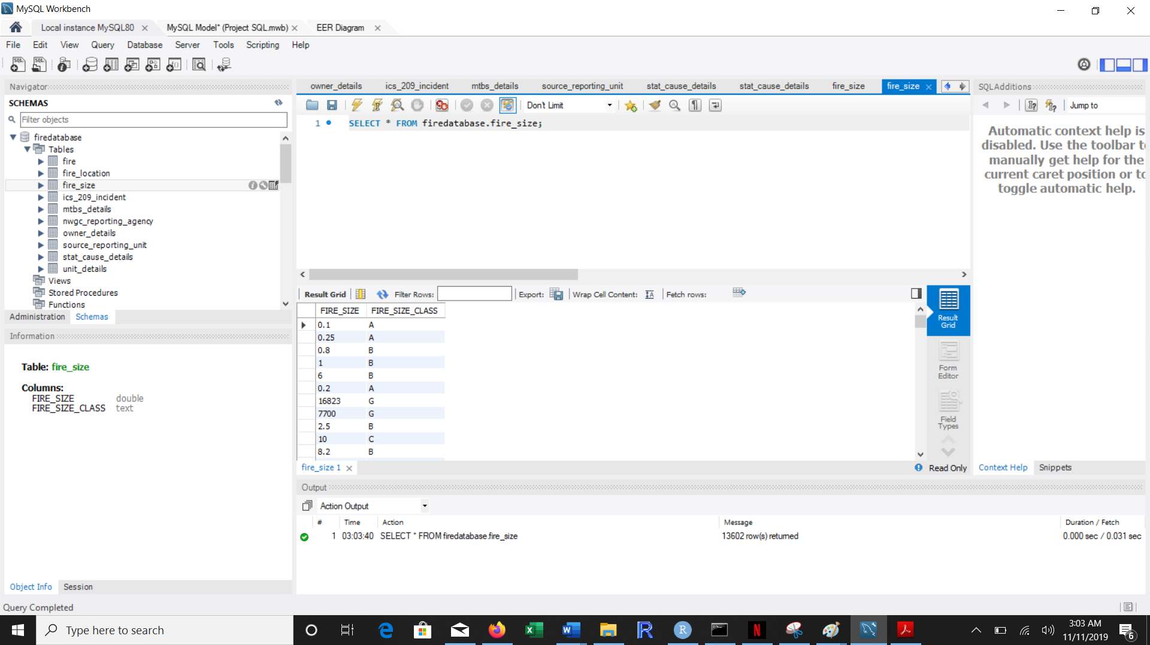

Fire location

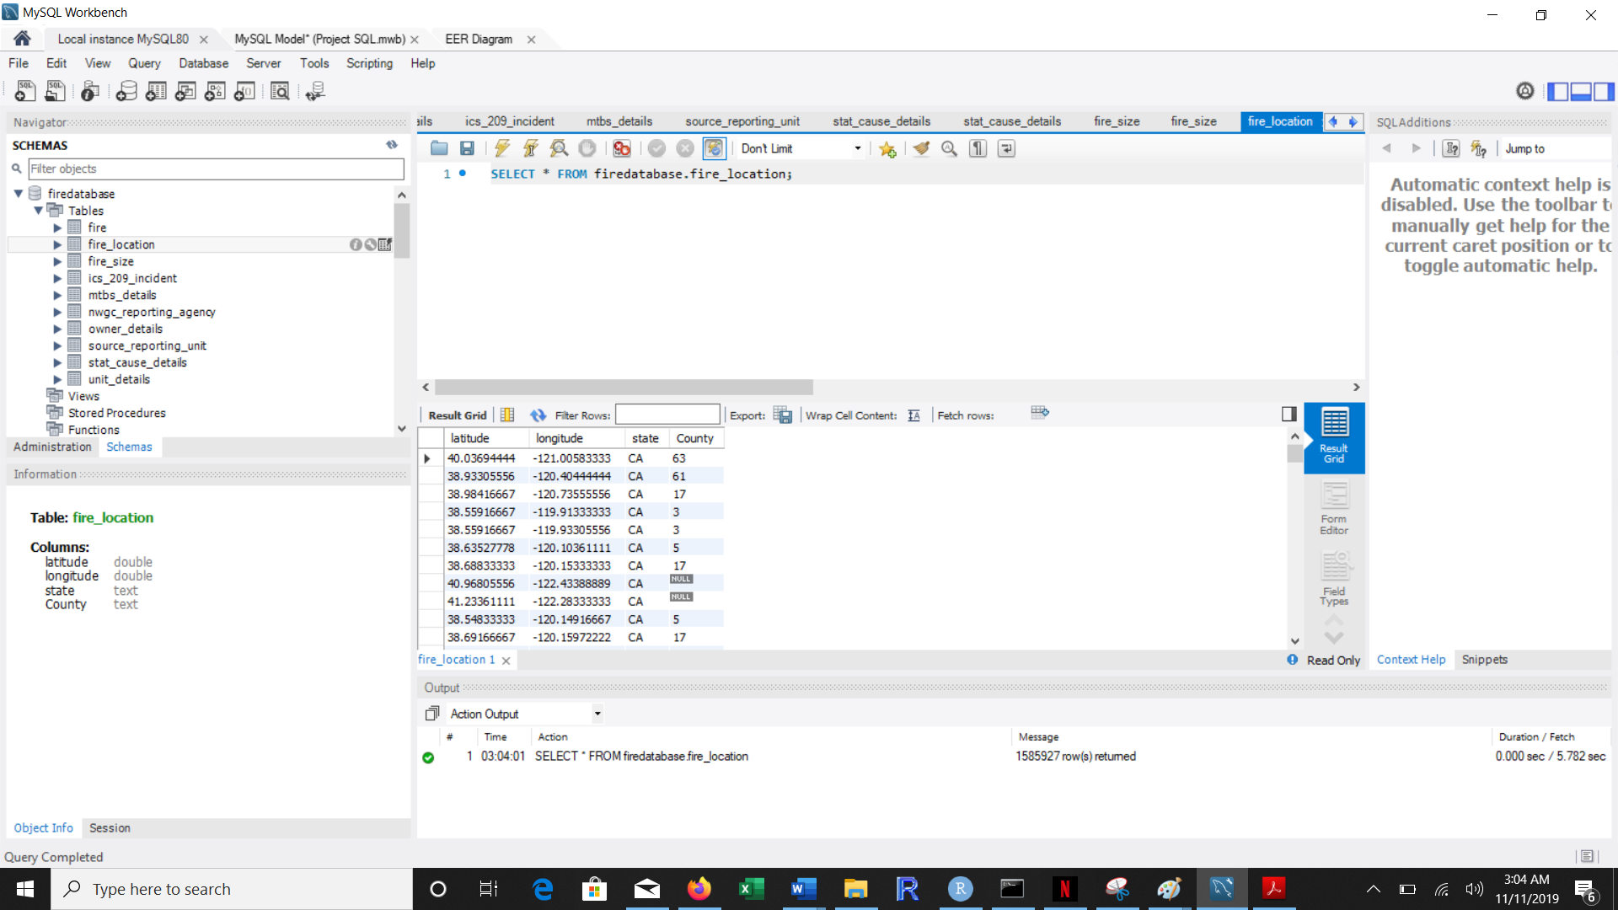

NWGC Unit Details

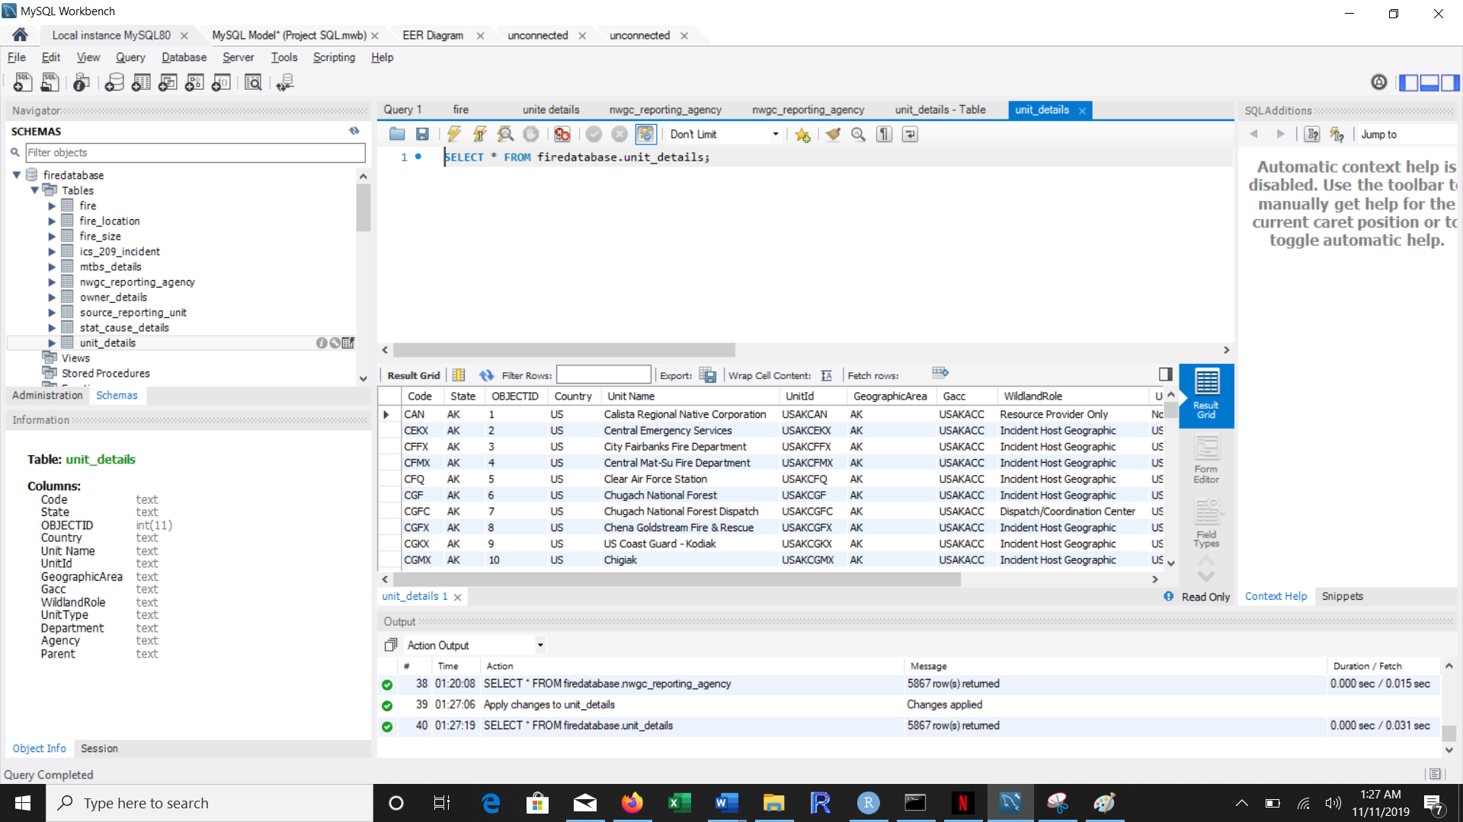

NWGC Reporting Agency

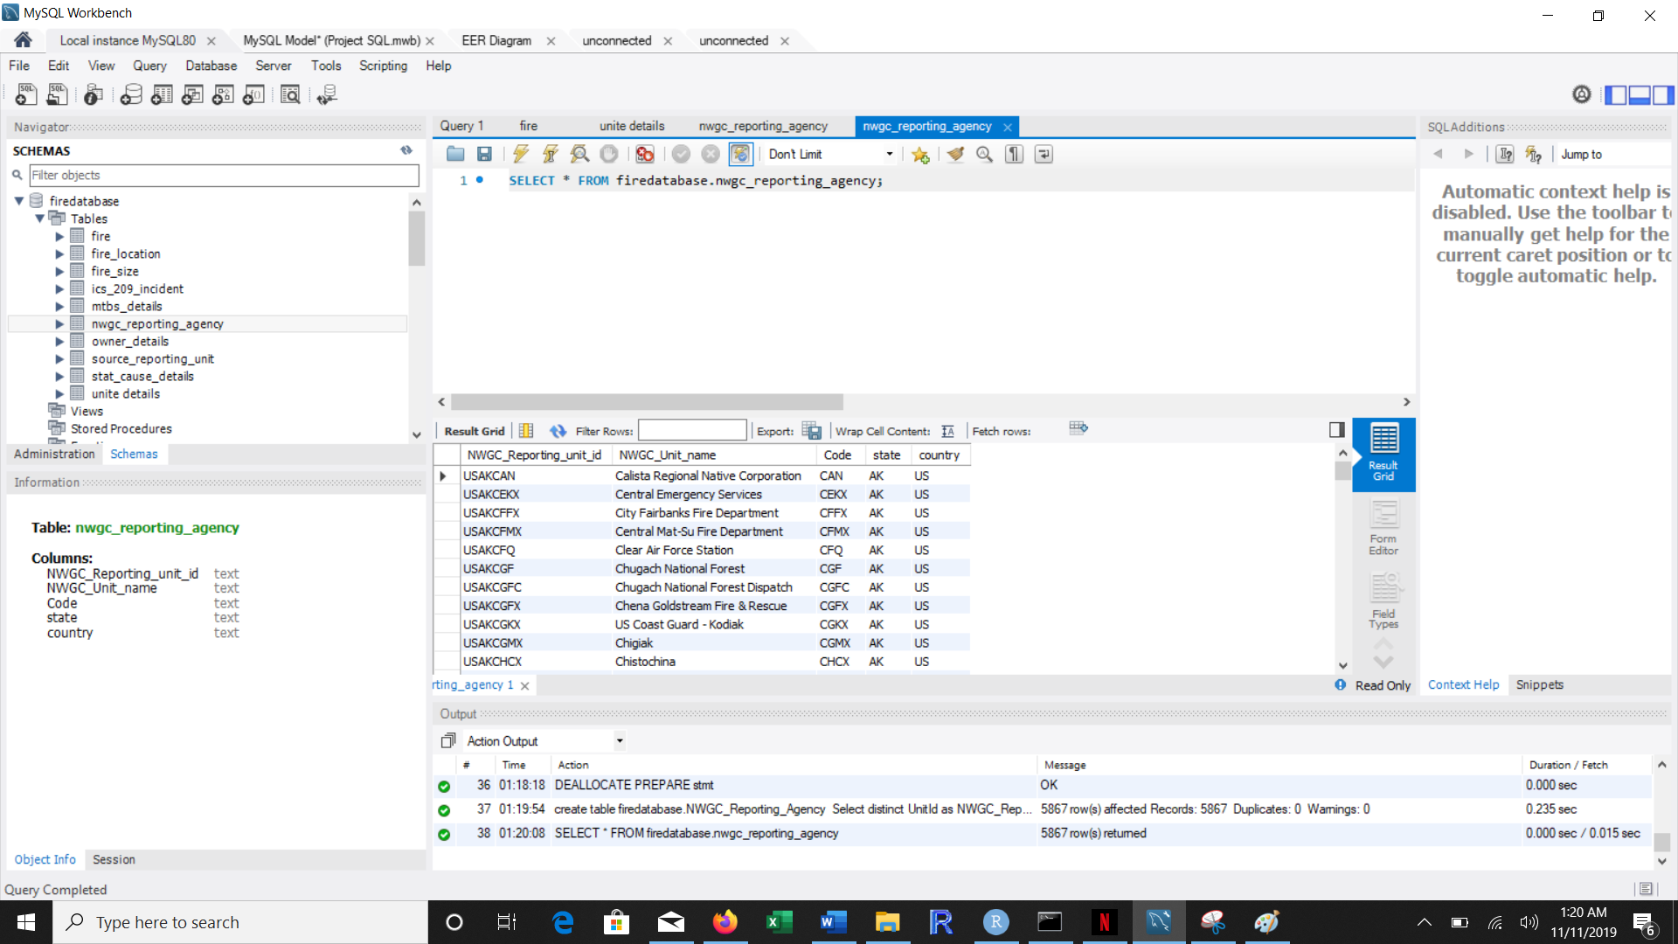

Owner details

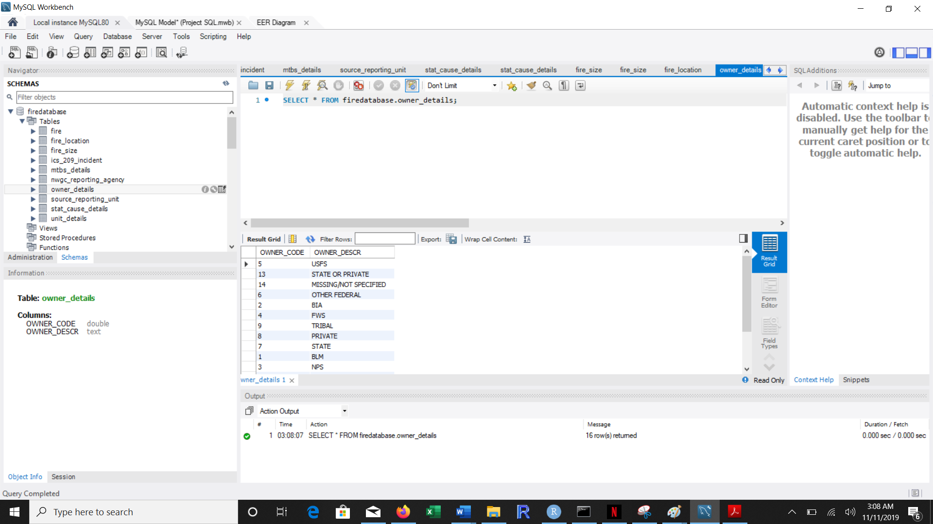

## Data in the Database

|  |  |  |  |
| --- | --- | --- | --- |
| **Table Name** | **Primary Key** | **Foreign Key** | **# of Rows in Table** |
| FIRE | FOD_ID | Latitude  Longitde  NWGC_Reporting_Unit_Id  Unit_Details_Code  Unit_Details_State  Unit_Details_Country  Fire_Size  Stat_Cause_code  Source_Reporting_Unit  ICS_209_INCIDENT_NUMBER  Owner_Code  MTBS_ID | 1880465 |
| ICS_209_INCIDENT | ICS_209_INCIDENT_NUMBER |  | 23313 |
| MTBS Details | MTBS_ID |  | 10481 |
| SOURCE_REPORTING_UNIT | SOURCE_REPORTING_UNIT |  | 6646 |
| STAT_CAUSE Details | Stat_Cause |  | 13 |
| Fire_Size | Fire_Size |  | 13602 |
| Fire_Location | Latitude  Longitde |  | 1585927 |
| Unit_Details | Code  State  Country |  | 5867 |
| NWGC_Reporting_Agency | NWGC_REPORTING_UNIT | Code State  Country | 5867 |
| Owner_Details | OWNER_CODE |  | 16 |

# SQL Queries

## Query 1

### Question 1

A leading beverage company has announced a billion-dollar fund for removing debris from forests, rivers and mountains in the US. All states are interested. Which 2 states have the least chance to win a share of the fund?

### Notes/Comments About SQL Query and Results (Include # of Rows in Result)

Number of rows #2

### Translation

Select NWGC unit name and State of the Agency

From Fire Table

Joining NWGC Reporting agency table and Fire table on NWGC Unit ID

On condition where stat_cause_code is equal to 5

Sorting in ascending order with respect to Stat Cause code

-- Clean Up --

/* select sr.NWGC_Unit_name as Forest_Name, f.STATE

from fire as f

Join nwgc_reporting_agency as sr on f.NWCG_REPORTING_UNIT_ID = sr.NWGC_Reporting_unit_id

where f.STAT_CAUSE_CODE = 5

group by f.STATE

order by count(f.STAT_CAUSE_CODE) asc

Limit 2;*/

### Screen Shot of SQL Query and Results

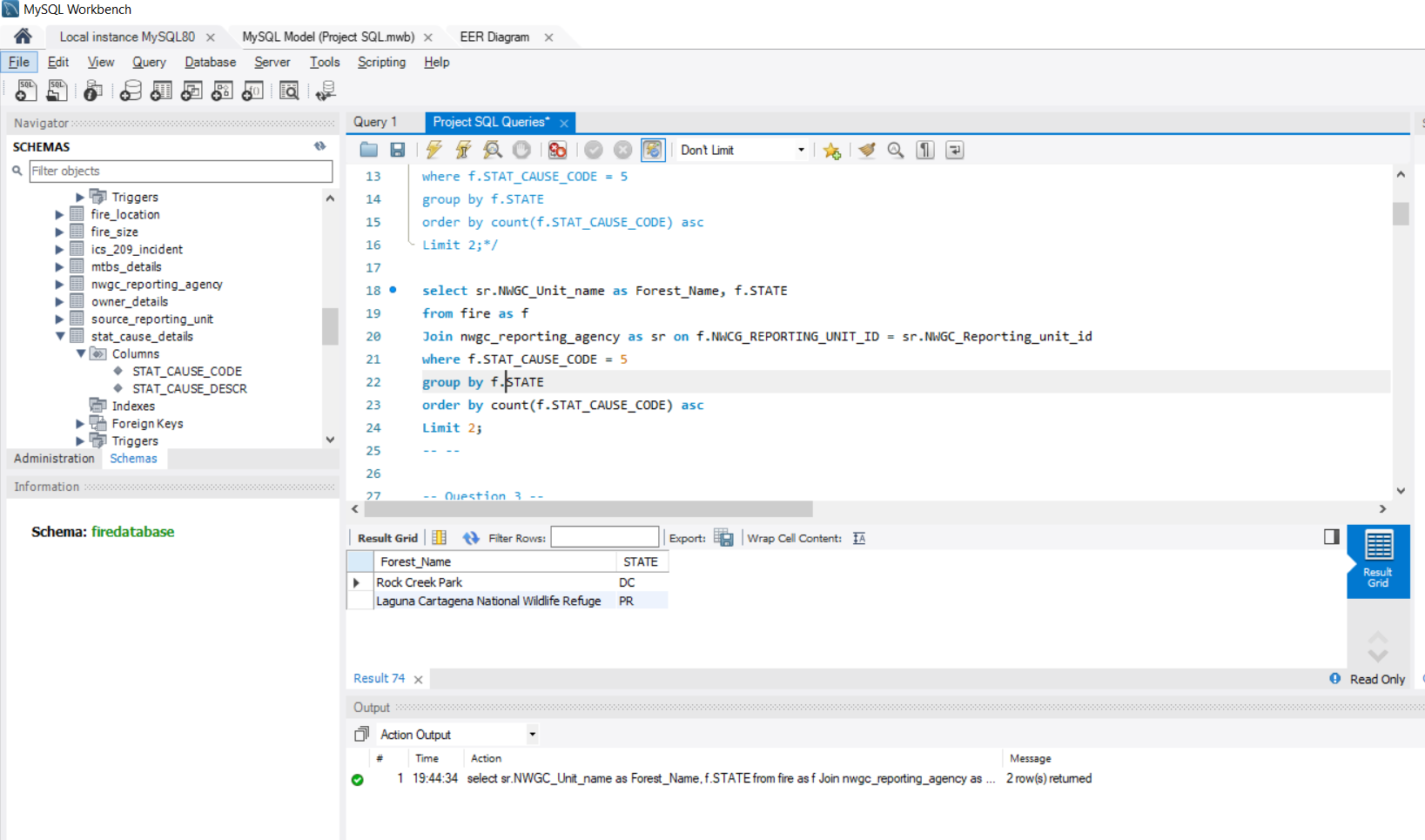

Conclusion: The 2 states have the least chance to win a share of the fund are DC and PR

## Query 2

### Question 3

One advocacy group says human actions and nature are equally to blame for most wildfires. Write a query that can help determine the truth of this statement.

### Notes/Comments About SQL Query and Results (Include # of Rows in Result)

Number of rows #1

Comments: The statement one advocacy group says human actions and nature are equally to blame for most wildfires is not true

Assumption: Considered Lightning as Natural cause and not including miscellaneous and Unidentified

### Translation

Count the causes of fire which was caused by Human and using a subquery to find count of fire caused Naturally

From the fire table

using condition where the stat_code = 1 for Lightning and rest stat_code for fire caused by Human

-- Clean up --

/* select count(STAT_CAUSE_CODE) as Human_cause,(select count(STAT_CAUSE_CODE) from fire where STAT_CAUSE_CODE = '1') as Natural_cause

from fire

where STAT_CAUSE_CODE <> 9 And STAT_CAUSE_CODE <> 1 and STAT_CAUSE_CODE <> 13; */

### Screen Shot of SQL Query and Results

Conclusion: The statement one advocacy group says human actions and nature are equally to blame for most wildfires is not true

## 

## Query 3

### Question 5

How many wildfires were reported by at least two units/agencies?

### Notes/Comments About SQL Query and Results (Include # of Rows in Result)

Number of rows #79358 76281

### Translation

Select Fire Description and count of the units/agency

from the fire table

joining the NWGC Reporting Agency table with fire table

grouping by fire name from fire table

using condition where count of the NWGC Reporting unit id is at least 2

-- Clean up --

/*

select f.FIRE_NAME, count(sr.NWGC_Reporting_unit_id) as Count_Fire_Reported

from fire as f

Join nwgc_reporting_agency as sr on f.NWCG_REPORTING_UNIT_ID = sr.NWGC_Reporting_unit_id

group by f.FIRE_NAME

having count(sr.NWGC_Reporting_unit_id) >= '2'

order by 2 ; */

### Screen Shot of SQL Query and Results

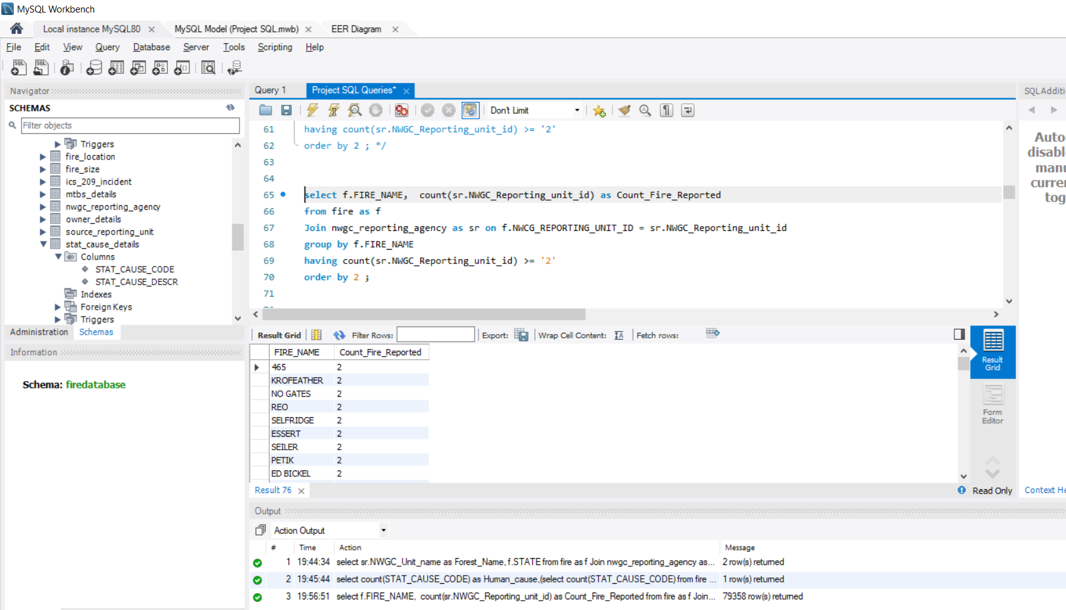

Conclusion:The number of wildfires reported by at least two agencies/units are 79358

## Query 4

### Question 6

What were the forests that had only one fire that lasted more than two days?

### Notes/Comments About SQL Query and Results (Include # of Rows in Result)

Number of rows #33

### Translation

Select NWGC Unit name and Count of FOD_ID

from the fire table

joining NWGC Reporting agency and Fire table

using condition where the differnce between the Discovery day of the year and Controll day of the year is greater than 2 and count of FOD_ID is equal to 1

Sorting in ascending order with respect to count of FOD_ID

-- Clean up --

/* select sr.NWGC_Unit_name as Forest_Name, count(f.FOD_ID) As Fire_Occurrence

from fire as f

Join nwgc_reporting_agency as sr on f.NWCG_REPORTING_UNIT_ID = sr.NWGC_Reporting_unit_id

where (DISCOVERY_DOY - CONT_DOY) > '2'

group by f.NWCG_REPORTING_UNIT_ID

having count(f.FOD_ID) = 1

Order BY count(f.FOD_ID) asc; */

### Screen Shot of SQL Query and Results

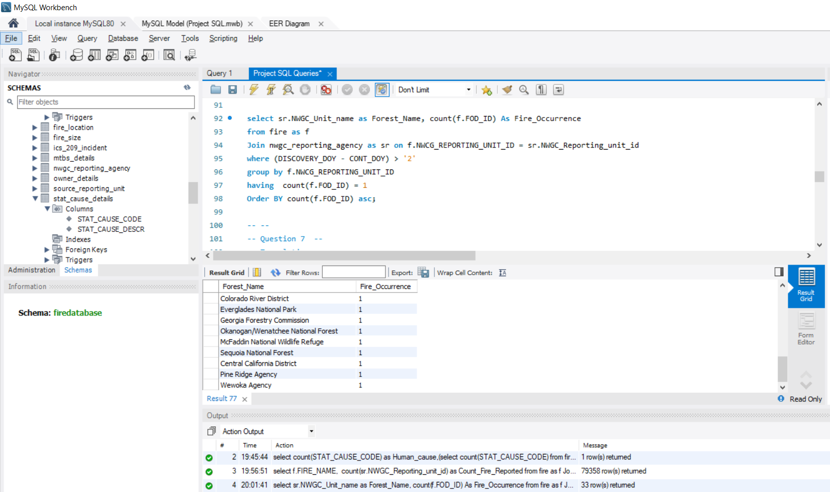

## Query 5

### Question 7

Which state had fires only in the second half of the calendar years?

### Notes/Comments About SQL Query and Results (Include # of Rows in Result)

Number of rows # 0

### Translation

-- Translation --

/* Select the state

from the fire table

where the Discovery day of the year is greater than or equal to 183 days only

and grouping by with respect to STATE */

-- Clean up --

/* Select gt.State,gt.H2_fires_cnt,lt.H1_fires_cnt from

(SELECT STATE, COUNT(FOD_ID) as H2_fires_cnt

FROM fire

WHERE DISCOVERY_DOY > '183' GROUP BY STATE) as gt

Join (SELECT STATE, COUNT(FOD_ID) as H1_fires_cnt

FROM fire

WHERE DISCOVERY_DOY <= '183' GROUP BY STATE) as lt

on gt.STATE=lt.STATE Where gt.H2_fires_cnt> 0

and lt.H1_fires_cnt = 0; Screen Shot of SQL Query and Results

### Screen Shot of SQL Query and Results

## 

Conclusion: There were fire in all the state all round the year and the output is blank because there was no state in which there was fire only in second half of the calendar years.

## Query 6

### Question

Which forest had the number of fires equal to the average number of wild fires in the US?

### Notes/Comments About SQL Query and Results (Include # of Rows in Result)

Number of rows # 0

### Translation

-- Translation --

/* Select the source reporting unit name as the forest name and count of the FOD_ID

from the fire table

joining the source reporting unit and fire table

grouping by with respect to the source reporting unit

using subquery as a condition where

fire count equals to average count of the fire that were reported by unit in the state US

*/

-- Sub Query Translation --

/*selecting the avg count

from the fire table

joing the fire and unit details table

using condition where the country is US */

-- Clean up --

/* select sr.SOURCE_REPORTING_UNIT_NAME as Forest_Name, count(f.SOURCE_REPORTING_UNIT) as Fire_Count

from fire as f

Join source_reporting_unit as sr on f.SOURCE_REPORTING_UNIT = sr.SOURCE_REPORTING_UNIT

Where "Fire_Count" =

(select avg(Count) from

(select f.STATE, ud.Country, f.FOD_ID as Count

from fire as f

join unit_details ud on f.STATE = ud.State

where ud.Country = 'US'

Group by f.STATE) as Counts)

group by sr.SOURCE_REPORTING_UNIT_NAME; */

### Screen Shot of SQL Query and Results

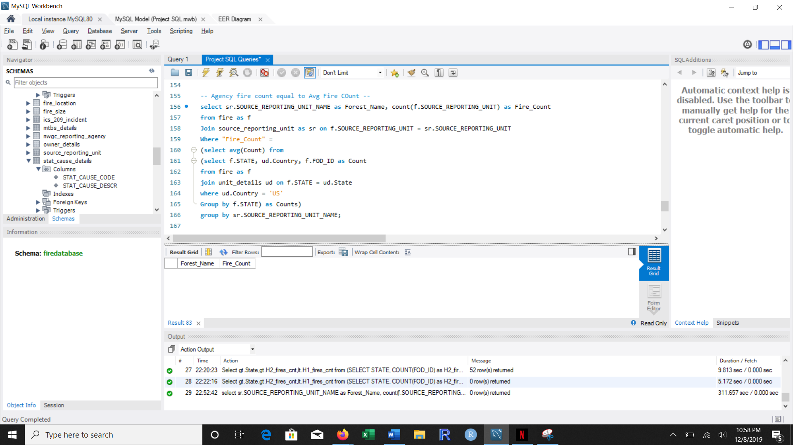

Conclusion: The avg number of wildfires in US was 61857.3077 and no forest has number of fires equal to the average number of wild fires in US therefore the output is blank.

# **Data Review for MongoDB**

## **Assumptions/Notes About Data Collections, Attributes and Relationships between Collections**

# Physical Mongo Database

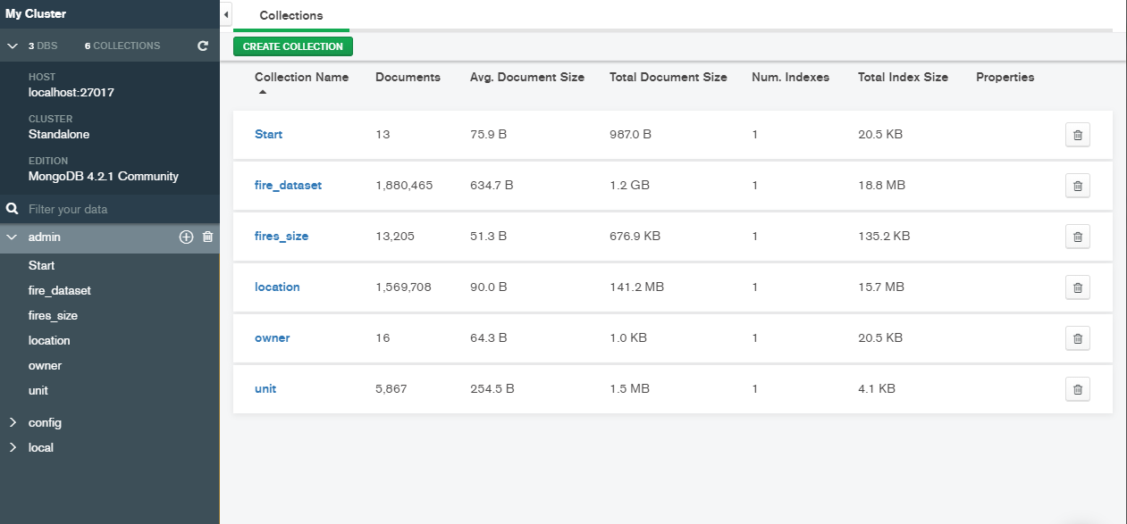

## **Assumptions/Notes About Data Set**

Fires:  
We have divided the data in Fire into 5 tables:

1. Fire_data: We have kept this table at FOD_ID level, keeping all the necessary columns that explains the details about the fire. The number of rows in this table is 1.8million which is the unique number of fire records. There are a few unitIDs present in fires table that are not available in the UnitID.
2. Fire_Size_Details: We have kept this table at fire_size level and their classes. There has been a reduction of total rows to 13k, where the class is only dependent on the size.
3. Location: We have kept this table at LATITUDE and LONGITUDE level. where the combination is unique across the table and state and country depend only on this combination
4. Owner_Details: We have kept this table at an OWNER_CODE level where the description of the code is only dependent on the code. There is a total of 16 unique owner codes.
5. Stat_Cause_Details: We have STAT_CAUSE_CODE as the primary key, where the description of the cause is solely dependent on the code. There is a total of 13 unique codes.

NWCG_unitActiveID:

We have included the data in NWCG_UnitIDActive_20170109 in Unit_Details table having Country, State and Code as primary keys. The unit id is a combination of these three columns in the said order therefore we have not included the unitID columns

**Screen shot of Physical Database objects (Database, Collections and Attributes)**

**Start:**

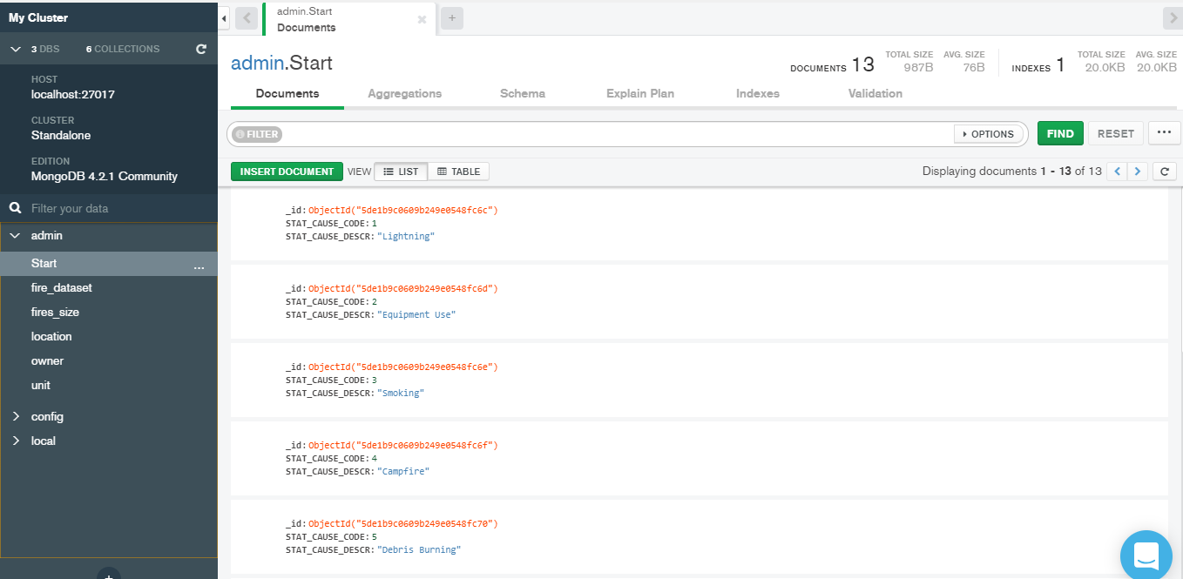

**Fire_dataset:**

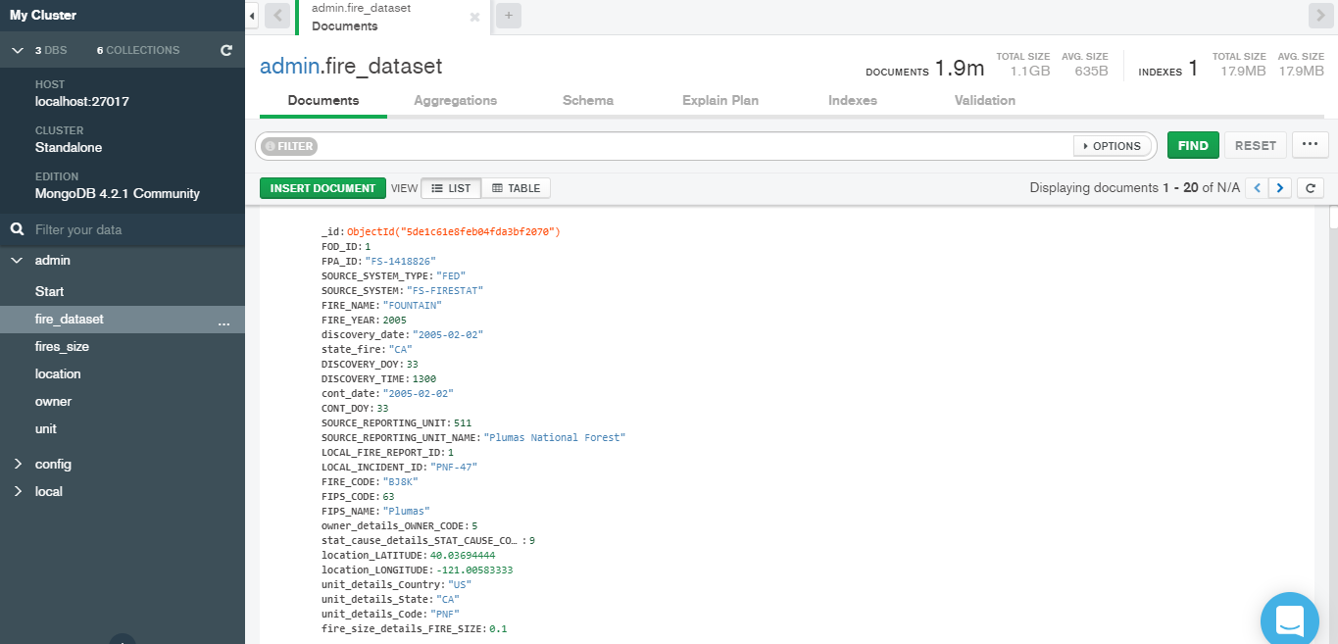

**Fires_size:**

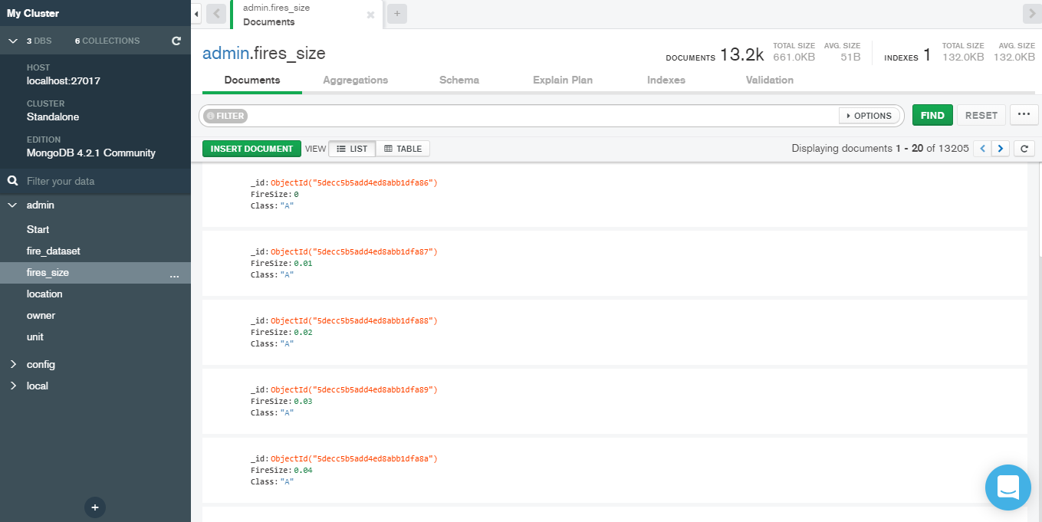

**Location:**

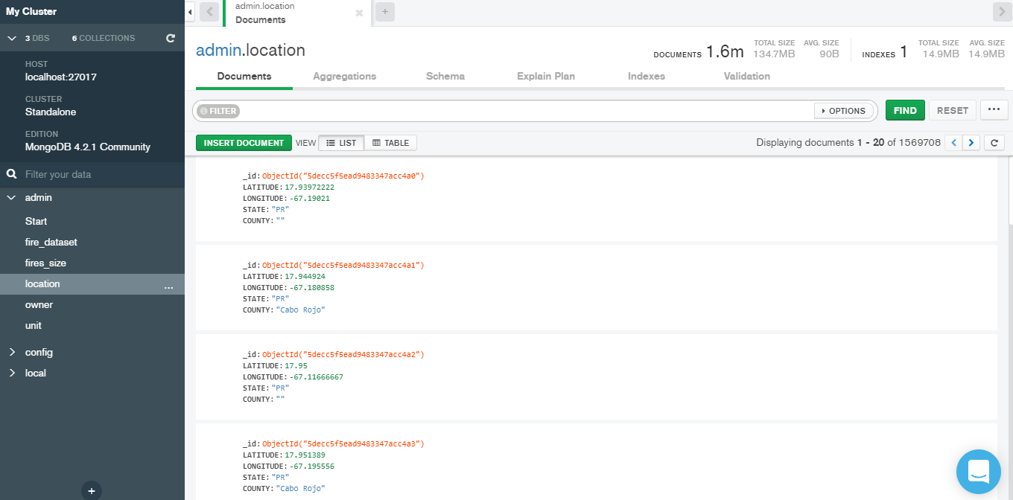

**Owner:**

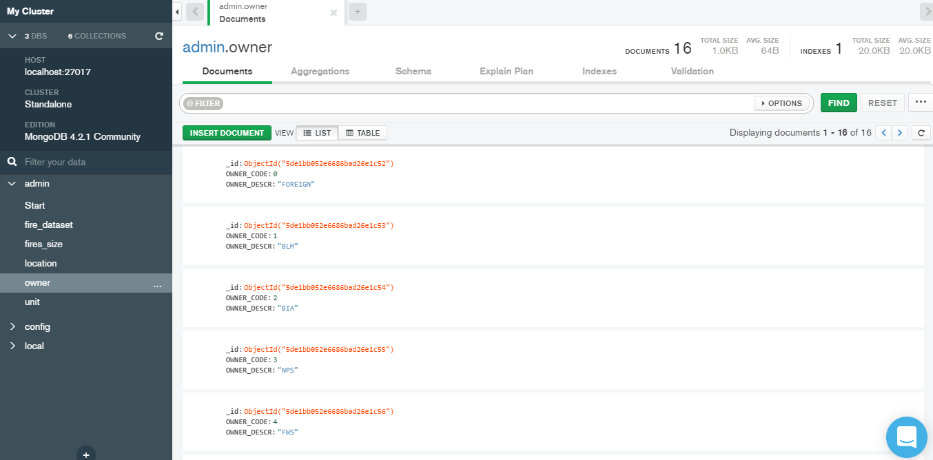

**Unit:**

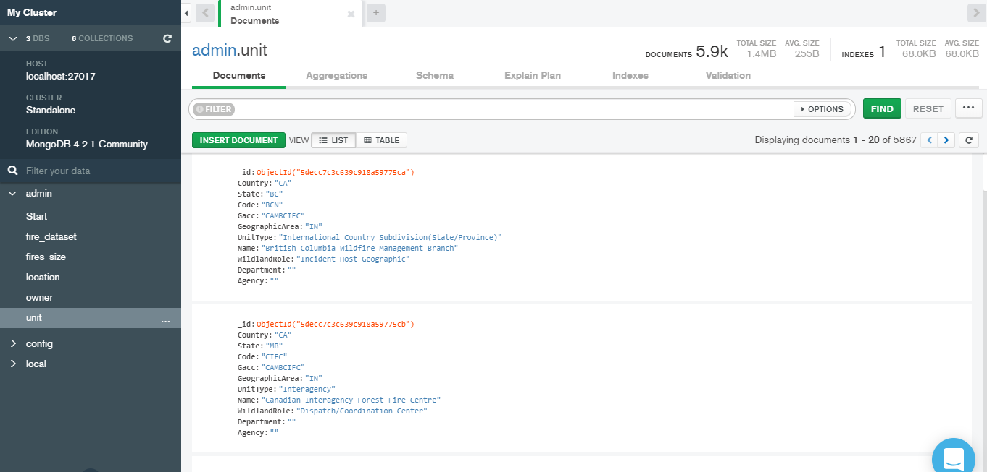

**Data in Database**

|  |  |  |
| --- | --- | --- |
| Collection Name | Relationships With Other Collections (if any) | # of Documents in Collection |
| fire_dataset | Contains field of fires_size : Fire_Size, owner: Owner_Code, start: Stat_Cause_Code, location: Latitude, Longitude, unit: Country, State, Code | 1.9 million |
| start |  | 13 |
| fires_size |  | 13.2k |
| location |  | 1.6 million |
| owner |  | 16 |
| unit |  | 5.9k |

# MongoDB Queries/Code

**Query 1:**

**Question1:**

A leading beverage company has announced a billion-dollar fund for removing debris from forests, rivers and mountains in the US. All states are interested. Which 2 states have the least chance to win a share of the fund?

**Assumption:**

Assume that the more the area affected by the fire, more is the debris. By calculating the area affected by the fire in each state, we can assume the amount of debris in that particular area and conclude that the least debris area states are least likely to receive the funding.

**Translation:**

We need the Fires collection to apply aggregate function. We then need to group the records by States and sum the variables Fire_Size. Sorting the records according to Fire_Damage in ascending order and limiting the records to 2 will return the 2 states that have the least chance to win a share of the fund.

**Cleanup:**

Select Fires collection using aggregate function to return States with 2 lowest Fire_sizes by grouping the documents according to State and aggregating Fire_Size values in ascending order.

**Syntax:**

db.fires.aggregate({ $match : { STAT_CAUSE_DESCR: "Debris Burning" } },{$group: {_id:"$STATE", count:{$sum:1}}},{$sort:{count:1}},{$limit:2},{$project:{_id:1}});

**Screen Shot of MongoDB Query/Code and Results:**

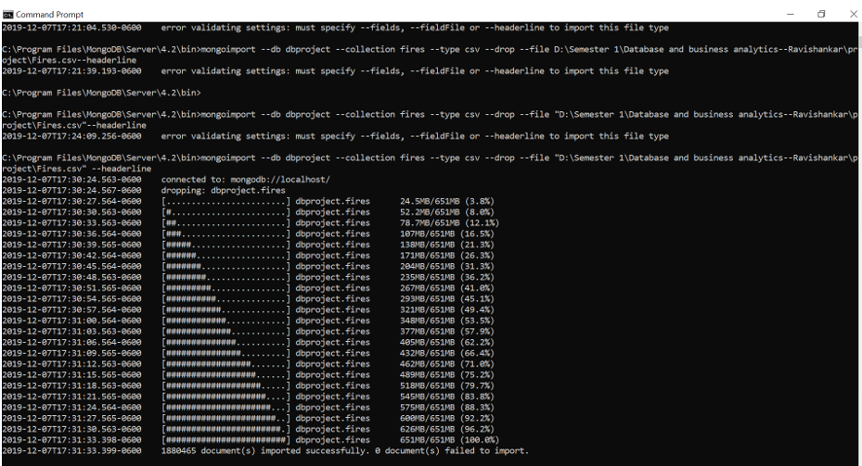

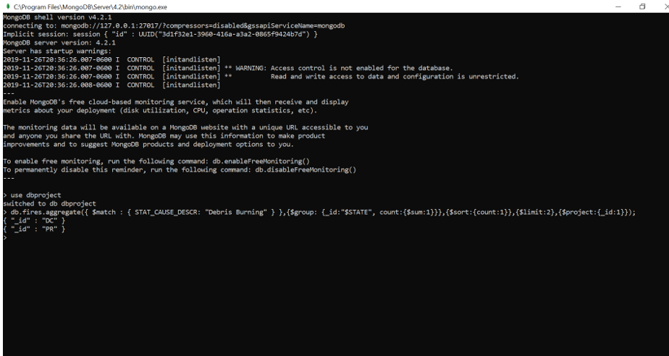

**Conclusion:** Hence, we conclude that DC and PR are the 2 states which are least likely to get the funding.

**Query 2:**

**Question 2:**

One of the reporting agencies has suggested that children be banned from its forests unless there is one adult for every 4 children in a group visiting a forest. Name top 5 forests where this would be the least appropriate.

**Assumptions:**

Considering only the forests whose fire caused was due to children have suggested that children need to be banned. Among the forests where the fires have been caused by children, the lowest 5 caused due to children would be least appropriate.

**Translation:**

Select from the Fires table and perform aggregate functions like $match for SOURCE_REPORTING_UNIT_NAME which starts with the Forest word and have Stat_Cause_Code equal to 8, $group for grouping the documents based on id equal to SOURCE_REPORTING_UNIT_NAME and calculating Firescount for each corresponding groups, $sort for returning the documents according to Firecount in ascending order, $limit equal to 5 for getting the results of the top 5 trees.

**Cleanup:**

Select from Fires table using aggregate functions like $match SOURCE_REPORTING_UNIT_NAME =/Forest$/ and Stat_Cause_Code= 8, $group by SOURCE_REPORTING_UNIT_NAME and Firescount for each corresponding groups, $sort according to Firecount in ascending order, $limit 5.

**Syntax:**

db.fires.aggregate({ $match : { STAT_CAUSE_DESCR: "Children" } },{$group: {_id:"$SOURCE_REPORTING_UNIT_NAME", count:{$sum:1}}},{$sort:{count:1}},{$limit:5},{$project:{_id:1}});

**Screen Shot of MongoDB Query/Code and Results:**

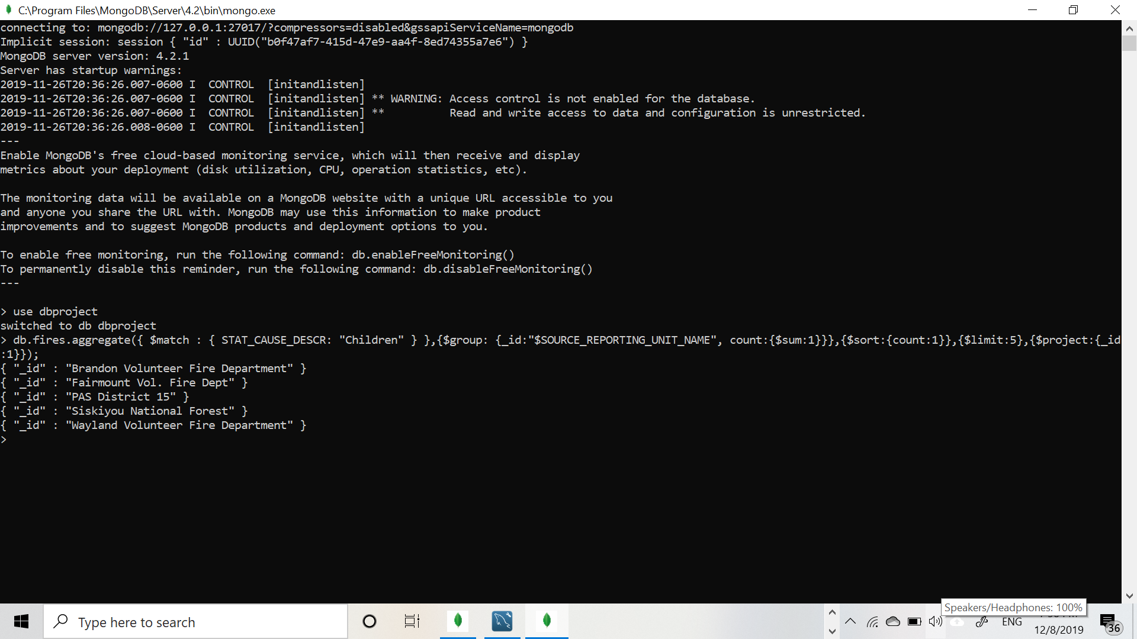

**Conclusion:** Hence, we conclude that Brandon, Fairmount, PAS, Siskiyou, Wayland are the top 5 forests where it would be least appropriate to ban children

**Query 3:**

**Question3:**

One advocacy group says human actions and nature are equally to blame for most wildfires. Write a query that can help determine the truth of this statement.

**Assumptions:**

Assuming **Lightening** is considered as the fire due to nature and the rest are caused by human excluding miscellaneous and missing/undefined causes as they are not specified.

**Translation:**

Choose Fires collection and apply $match function for STAT_CAUSE_DESCR and key not in “Miscellaneous”,”Missing/Undefined”, $project for.

**Cleanup:**

Select Fires collection to return State with lowest Fire_size by group the documents according to State and aggregating Fire_Size values in ascending order.

**Syntax:**

db.Fires.aggregate([

{$match:{STAT_CAUSE_DESCR: {$nin: [“Miscellaneous”,”Missing/Undefined”]}}},

{

$project:

{

“STAT_CAUSE_DESCR”:1,

“summary”:

{

$switch:

{

Branches: [

{ case: { $eq : [ ‘$STAT_CAUSE_DESCR’,”Lightning”]}, then: “Nature”},

],

default: ”Human”

}

}

}

},

{$group: {_id: “$summary”, count: {$sum:1}}}

])

**Screen Shot of MongoDB Query/Code and Results:**

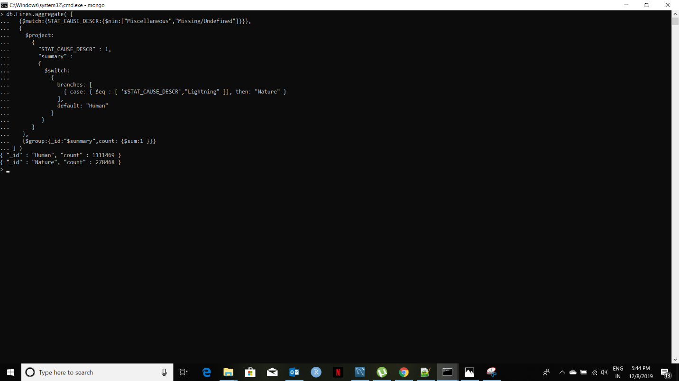

**Conclusion:**

Hence, we can conclude that both humans and nature are responsible for the fires and they are not to be blamed equally as more wildfires have been caused by humans.

## **Query 4:**

**Question4:**

What are the top two unit types that reported wildfires in each state in the US?

**Assumptions:**

Assuming Unit types is Source_system_type, we find where the wildfires have occurred the most.

**Translation:**

Choose Fires collection and apply $match function for SOURCE_SYSTEM_TYPE and sort it in descending order and projecting the highest 2 unit types wildfires reported states.

**Cleanup:**

Select Fires collection to return State with top 2 units where most wildfires have occurred and grouping the documents according to State and aggregating the values in desceding order.

**Syntax:**

db.fires.aggregate({$group: {_id:"$SOURCE_SYSTEM_TYPE", count:{$sum:1}}},{$sort:{count:-1}},{$limit:2},{$project:{_id:1}});

**Screenshot:**

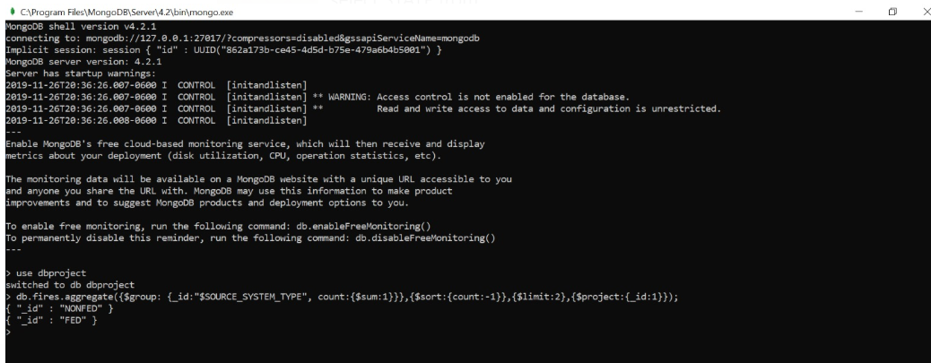

**Conclusion:**

Hence, we conclude that the top 2 units which reported wildfires in each state in the US are Nonfeed and Feed

**Query 5:**

**Question5:**

How many wildfires were reported by at least two units/agencies?

**Assumptions:**

Assuming that the reporting agency is the SOURCE_REPORTING_UNIT_NAME, we find the FIRE_NAME who have greater than or equal to 2 SOURCE_REPORTING_UNIT_NAMEs.

**Translation:**

Displaying documents according to FIRE_NAME and SOURCE_REPORTING_UNIT in ascending order, grouping the documents according to FIRE_NAME and summing up the SOURCE_REPORTING_UNIT, Finding the No_of_units_reported greater than or equal to 2, converting to Array and printing its length using toArray().length

**Cleanup:**

Select Fires collection and apply aggregate functions- $project FIRE_NAME and SOURCE_REPORTING_UNIT in asc, $group FIRE_NAME and sum SOURCE_REPORTING_UNIT, $match No_of_units_reported >= 2, toArray().length

**Syntax:**

db.fires.aggregate([{$group: {_id:"$FIRE_NAME",Number: {$sum: "$SOURCE_REPORTING_UNIT"}}},{$match: {Number:{$gte:2}}},

{$project:{FIRE_NAME:1,SOURCE_REPORTING_UNIT:1}}]).toArray().length

### 

**Screen Shot of MongoDB Query/Code and Results:**

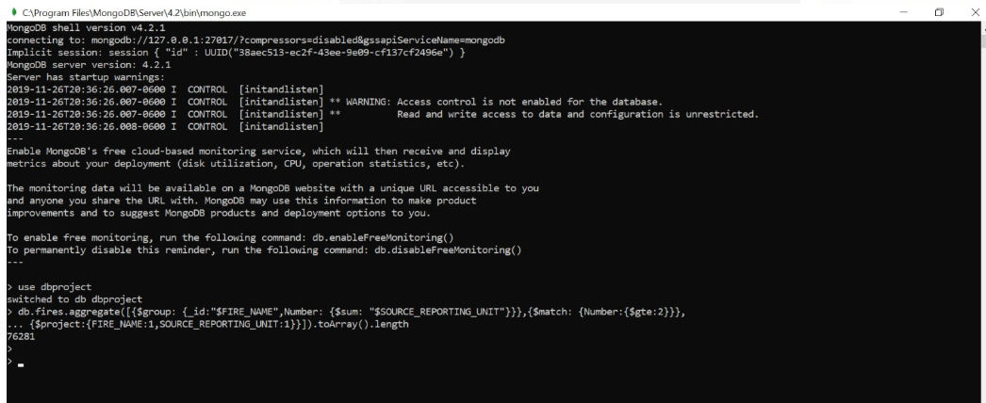

Conclusion: Hence, we conclude that 76281 wildfires were reported by atleast 2 units/agencies

**Query 6:**

**Question 6:**

What were the forests that had only one fire that lasted more than two days?

**Assumption:**

Assuming that the reporting agency is the SOURCE_REPORTING_NAME and considering only those

SOURCE_REPORTING_UNIT_NAME ending with Forest as forest(“%Forest) as forests and all the forests whose difference of CONT_DATE and DISCOVERY_DATE is greater than 2

**Translation:**

Select documents from Fires collection applying aggregate functions- $addfields adds new field date_diff to display the difference of Cont_Date and Discovery_Date, $match to display the date_diff greater than 2, $project to select the SOURCE_REPORTING_UNIT_NAME, $match for SOURCE_REPORTING_UNIT_NAME ending with the word Forest, $group to group the documents with SOURCE_REPORTING_UNIT_NAME, $project to display the

SOURCE_REPORTING_UNIT_NAME

**Cleanup:**

Select documents from Fires collection applying aggregate functions- $addfields adds date_diff to displaying (Cont_Date -Discovery_Date), $match for date_diff <=2, $project selects SOURCE_REPORTING_UNIT_NAME, $match for SOURCE_REPORTING_UNIT_NAME ending with the word Forest, $group groups documents according to SOURCE_REPORTING_UNIT_NAME, $project displays

SOURCE_REPORTING_UNIT_NAME

**Syntax:**

db.Fires.aggregate([

{ $addFields: { date_diff: { $subtract: ["$CONT_DATE", "$DISCOVERY_DATE"]} } },

{ $match: { date_diff: { $gt : 2} } },

{ $match: { "SOURCE_REPORTING_UNIT_NAME":/Forest$/ } },

{ $group: { _id:{SOURCE_REPORTING_UNIT_NAME: "$SOURCE_REPORTING_UNIT_NAME"}, Firescount:{$sum:1} } },

{$match: {Firescount:{$eq:1}}},

{ $project: { SOURCE_REPORTING_UNIT_NAME : 1 } },

])

**Screen Shot of MongoDB Query/Code and Results:**

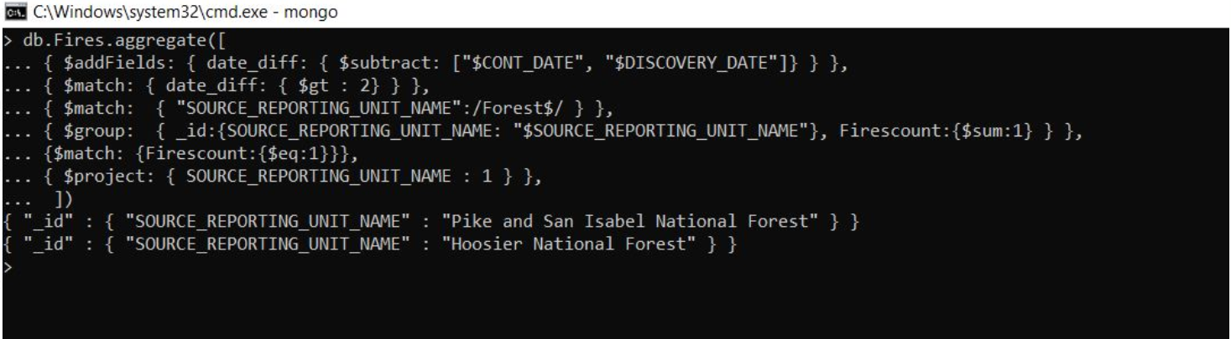

**Conclusion:** Hence, we conclude that Pike and San Isabel National forest and Hoosier National Forest are the forests that had fires which lasted more than 2 days.